Activity No. <n>
<Replace with Title>
Course Code: CPE010 | Program: Computer Engineering
Course Title: Data Structures and Algorithms | Date Performed:08/28/25
Section:CPE11S1 | Date Submitted:09/02/25
Name(s):NIELES, CENNDY M. | Instructor: ENG. JIMLORD QUEJADO
6. Output
7. Supplementary Activity
Exercise 4.1 : Try to create a simple program using C++ language that outputs your whole name. Using the new line syntax, output your program and the course and section.#

//This output my name. course and section
#include <iostream>
using namespace std;

int main() {
cout << “Cenndy Magbanua Nieles”<<endl;
cout << “CPE007”<<endl;
cout << “CPE11S1”<<endl”;
return 0;
}

INPUT

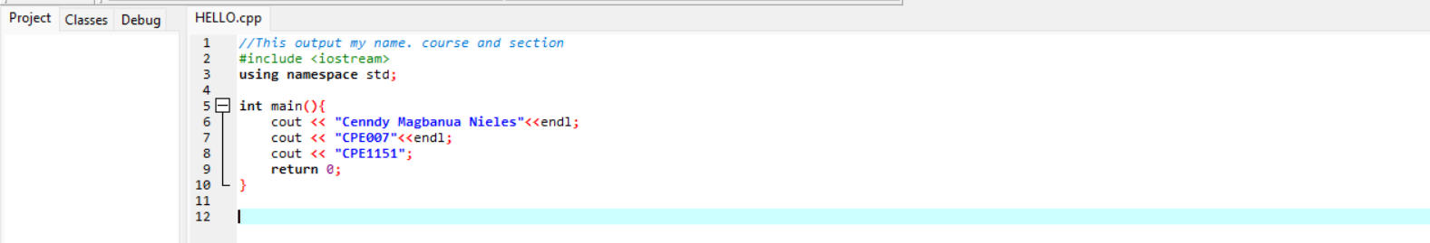

OUTPUT

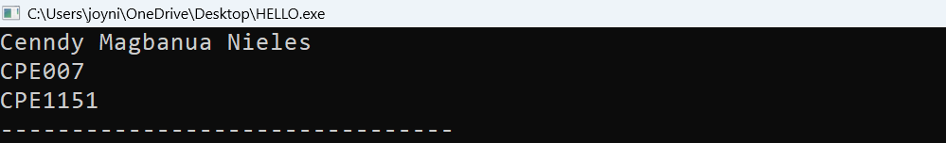

Exercise 4.2: Write a program in the "C++" language that prints your name 3 times. Remember to include a return statement and make proper use of the main function.

//This output my name. course and section
#include <iostream>
using namespace std;

int main() {
cout << “Cenndy Magbanua Nieles”<<endl;
cout << “Cenndy Magbanua Nieles”<<endl;
cout << “Cenndy Magbanua Nieles”<<endl”;
return 0;
}

INPUT
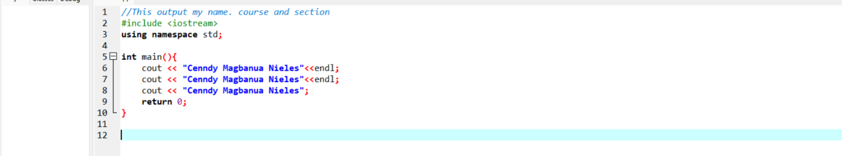

OUTPUT

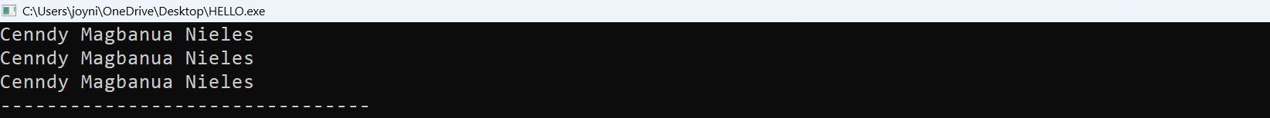

Check the program below. Find all possible compilation errors and logic errors. Fix them. Your version of the program must print the same result as the expected output. Before you use your compiler, try to find the errors only by manual code analysis.

#include <iostream>
int main()
{
cout(“The value of five is: “<< 5 int);
return 0;
}

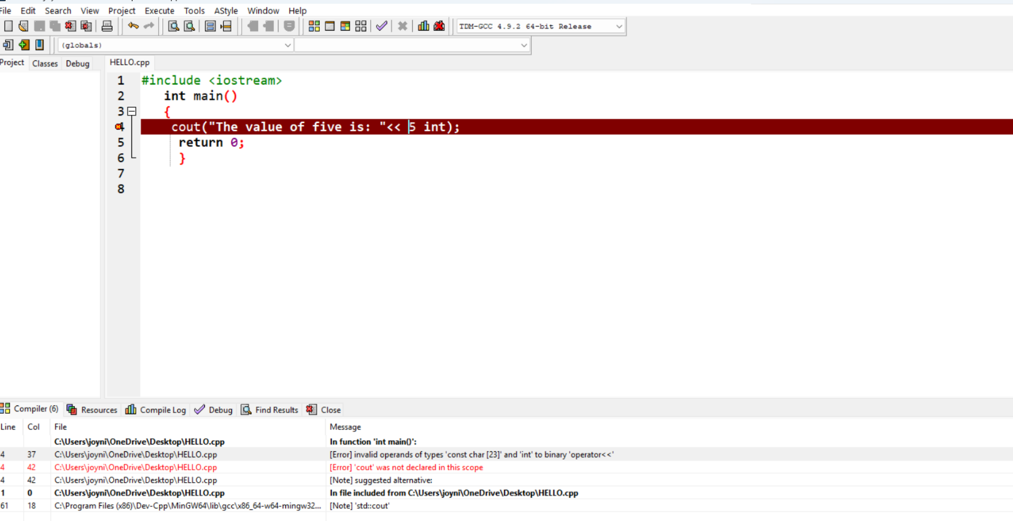

ERRORS CODE:

The errors is 5int it’s not a valid integer in C++ language

CORRECT CODE :

#include <iostream>
Int main() {
std::cout << “The value of five is:” <<5<<
std::endl;
return 0;
}

INPUT

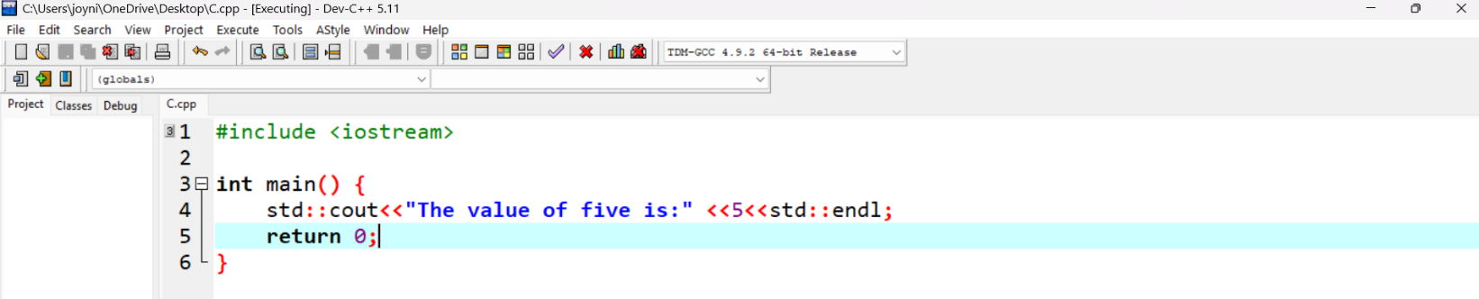

OUTPUT

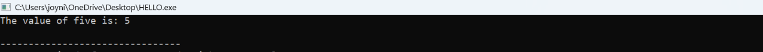

,
2. Check the program below. Find all possible compilation errors and logic errors. Fix them. Your version of the program must print the same result as the expected output. Before you use your compiler, try to find the errors only by manual code analysis.
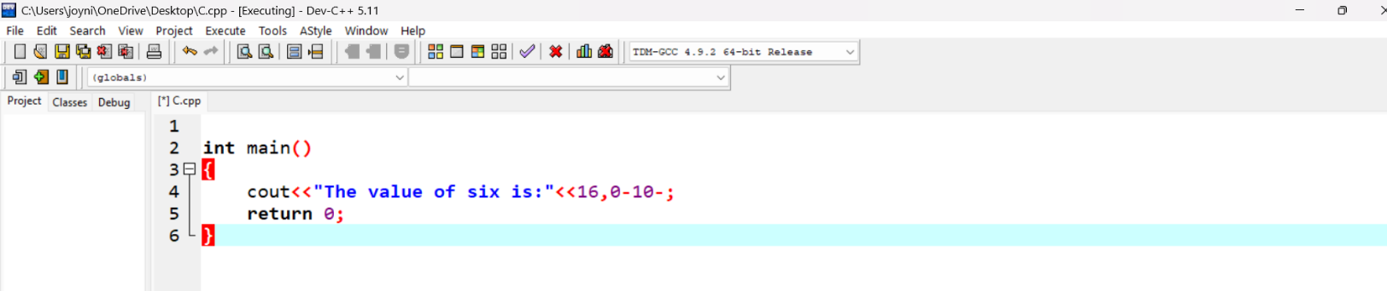

Int main()
{
cout<<”The value of six is: is:”<<16,0-10-;
return 0;
}

ERRORS CODE:
It attemps to use cout without including the required iostream. All input/output in C++ language need to include a header.The program is intended to print “The value of six is”,6,but the cout statement prints the literal string <16,010-> instead of the number 6.

CORRECT CODE:

#include <iostream>

int main () {

int six=6
std::cout <<”The value of six is:”<< six << std::endl;

INPUT:
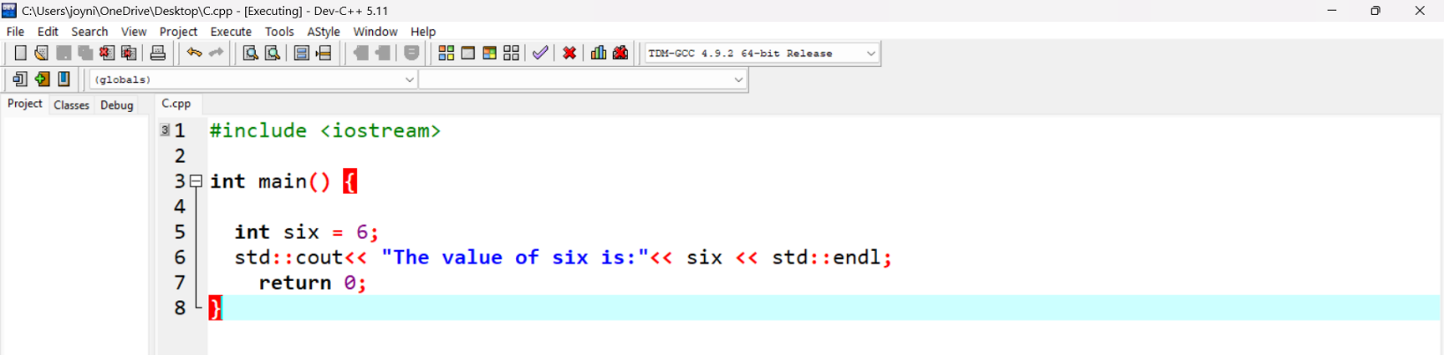

OUTPUT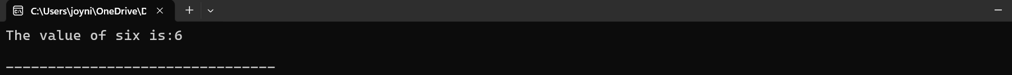

3. Check the program below. Find all possible compilation errors and logic errors. Fix them. Your version of the program must print the same result as the expected output. Before you use your compiler, try to find the errors only by manual code analysis. If you want to improve the variable names, then do so, but remember that variable names have to be as descriptive as possible, and also as short as possible.

#include <iostream>
Using namespace std;

int main ()
{
int simpleVariable = 10;
cout<<”The value of ten is:”<<otherVariable);
return 0;
}

ERROR CODE:

The code needs to use the variable simpleVariable to display its true. And
“<<otherVariable>>” is not variablename.

CORRECT CODE:

#include <iostream>
Using namespace std:

Int main() {
int simpleVariable ==10;
cout<<”The value of ten is:” << simpleVariable<<endl;
return 0;
{

INPUT:
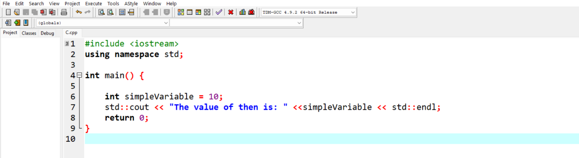
OUTPUT:

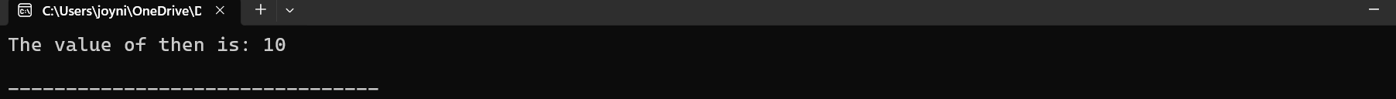

4. Check the program below. Find all possible compilation errors and logic errors. Fix them. Your version of the program must print the same result as the expected output. Before you use your compiler, try to find the errors only by manual code analysis. If you want to improve the variable names, then do so, but remember that variable names have to be as descriptive as possible, and also as short as possible.

#including <iostream>
Using namespace std;

int maint ()
{
Int 60seconds = 60;
Int 60minutes = 50;
Cout<<” One hour is “<<60seconds * 60minutes);
Return 0;
}

ERROR:
The compilation errors missing semicolons and its flawed because of variables 660minutes is assigned value of 50, but expected output requires a calculation.

CORRECT CODE;

#include <iostream>
Using namespace std:

int main() {
int sixty_seconds = 60;
int sixty_minutes = 60;
std::cout << "One hour is " << sixty_seconds * sixty_minutes << " seconds." << std::endl;
return 0;
}

INPUT;

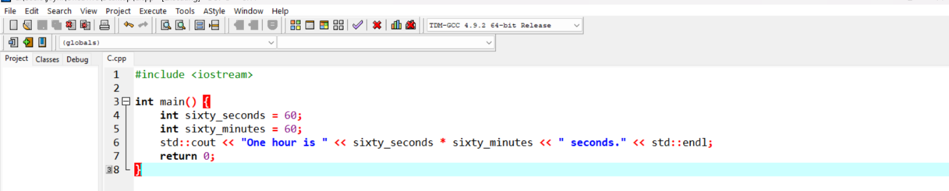
OUTPUT:

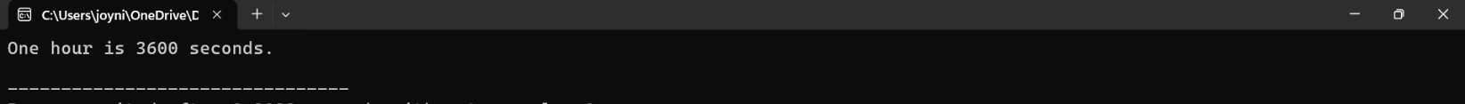

5. Check the program below. Find all possible compilation errors and logic errors. Fix them. Your version of the program must print the same result as the expected output. Before you use your compiler, try to find the errors only by manual code analysis. If you want to improve the variable names, then do so, but remember that variable names have to be as descriptive as possible, and also as short as possible.
#include <iostream>
Usingnamespace std;

Int main ()
{
Int ip Part1 = 021
Int ip Part2 = 0;
Int ip part3 = 0’
Int ip part 4 = 0;
cout <<”Localhost IP is “<< ip Part 1, ip Part 2, ip Part 3, ip Paart4);
{

ERROR:

The program won’t compile because it’s missing semicolons at the end of several statements. In the lines int ip Part2 =0 anad int ip Part3 = 0 are missing their required semicolons. And need a calculation so the expect output shows that the first part of the IP address should be 127.

CORRECT CODE;

#include <iostream>
using namespace std;

int main() {
int ipPart1 = 127;
int ipPart2 = 0;
int ipPart3 = 0;
int ipPart4 = 1;
cout << "Localhost IP is " << ipPart1 << "." << ipPart2 << "." << ipPart3 << "." << ipPart4 << endl;
return 0;
}

INPUT;
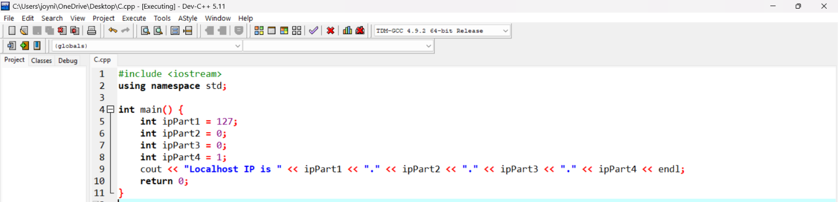

OUTPUT:
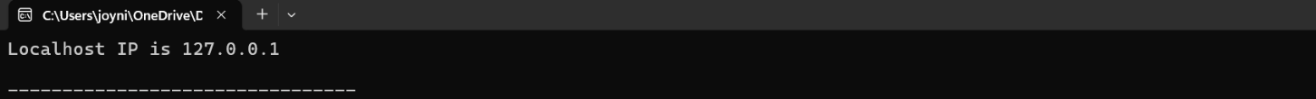

8.Conclusion;
Making a simple code and fixing a some error and learning debug in simple program. I have learn a new lesson using c++ even you need have a lot of time to finish it but yeah like me I have a short patience buts its enjoyable to learned you just needed to extend your patience.
9. Assessment Rubric

